-

Walmart Analysis

Table of Contents
1 Introduction 3
1.1 Setup Checklist for Mini Project 3
2 Problem Statement 4
2.1 Objective 4
2.2 Abstract of the project 4
2.3 Technology used: 4
3 Implementation 5
3.1 Summary of the functionality to be built: 5
3.2 Guidelines on the functionality to be built: 5

Introduction
Welcome to the BI Walmart Data Analysis Project, where we embark on a journey to uncover valuable insights from Walmart's vast and diverse dataset. In this project, we leverage the power of modern data analytics tools, including Snowflake, dbt (data build tool), and Tableau, to transform raw data into actionable intelligence, enabling data-driven decision-making for Walmart's business operations.

Requirement video
https://drive.google.com/file/d/1SOzumShXMegPpc9nfobaOrNxdqZfUvuQ/view?usp=sharing

DBT Courses
https://courses.getdbt.com/courses/fundamentals
https://courses.getdbt.com/courses/advanced-materializations
https://courses.getdbt.com/courses/jinja-macros-packages

optional
https://courses.getdbt.com/courses/dbt-cloud-and-snowflake-for-developers

  - Setup Checklist

Minimum System Requirements
- Snowflake Account
- DBT Cloud Account
- Any reporting tool

Problem Statement
  - Objective
To analyze the sales of Walmart.
  - Abstract of the project
To tackle the complexities of this project, we have adopted a powerful and scalable technology stack. We use Snowflake, a leading cloud data platform, as our data warehouse to store and manage Walmart's vast dataset securely and efficiently. Snowflake's elasticity and performance enable us to handle the ever-growing data demands of a retail giant like Walmart.

The heart of our data transformation and modeling lies in dbt (data build tool), a modern data engineering workflow that promotes collaboration, version control, and data lineage tracking. With dbt, we can confidently build, test, and deploy data models, ensuring data accuracy and consistency throughout the analysis process.

To visualize and explore the results of our data analysis, we rely on Tableau, a powerful business intelligence and data visualization platform. Tableau's intuitive interface and interactive dashboards empower Walmart's teams to interact with the data and gain actionable insights effortlessly.
  - Technology used:
- Snowflake (Database)
- DBT (Transformation Tool)
- Any Reporting Tool

Implementation
  - Summary of the functionality to be built:
You need to develop the Walmart analysis by building the dimension tables and fact tables in snowflake using DBT. Those tables will be ingested by Tableau to build required visualisations.

  - Guidelines on the functionality to be built:
Project flow

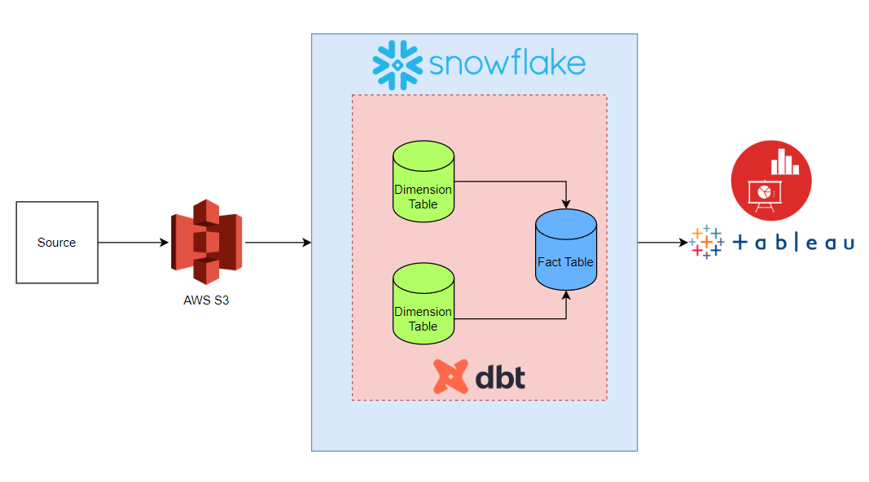

Dimension model:

Walmart_date_dim
Date_id | Int
Store_Date | Date
Isholiday | varchar
Insert_date | Timestamp
Update_date | Timestamp

Walmart_store_dim
Store_id | Int
Dept_id | Int
Store_type | Varchar
Store_size | Int
Insert_date | Timestamp
Update_date | Timestamp

Walmart_fact_table
Store_id (FK) | Int
Dept_id (FK) | Int
Store_Weekly_sales | Decimal
Fuel_price | Decimal
Store_temperature | Decimal
Unemployement | Decimal
CPI | Decimal
Markdown1 | Decimal
Markdown2 | Decimal
Markdown3 | Decimal
Markdown4 | Decimal
Markdown5 | Decimal
Insert_date | Timestamp
Update_date | Timestamp
Vrsn_start_date | Timestamp
Vrsn_end_date | Timestamp

Note: The datatype/length for the Dimension/Fact table attributes can be changed as required. Additional fields can be added, if required.

Do watch below videos for understanding SCD1 and SCD2
SCD1 using DBT
SCD2 using DBT

Data_Engineering_Basics_Videos
Watch above videos before starting any developement

This table will be SCD1 (upsert logic).
- Walmart_date_dim:

This dimension contains the date of each store.
- Date_Id (PK)
- Date
- Isholiday
- Insert_date
- Update_date

This table will be SCD1 (upsert logic).
- Walmart_store_dim:

This dimension contains about store details.
- Store_id (PK)
- Dept_id (PK)
- Store_type
- Store_size
- Insert_date
- Update_date

This table will be SCD2. Version out the older records for the provided FK and insert new record as new version. If there is new version for provided FK combination, you need to end the existing record from fact table and insert new version

- Walmart_fact_table:

This is a Fact table that contains foreign keys and measures.
- Store_id (FK)
- Dept_id (FK)
- Date_id (FK)
- Store_size
- Store_weekly_sales
- Fuel_price
- Temperature
- un-employement
- CPI
- Markdown1
- Markdown2
- Markdown3
- Markdown4
- Markdown5
- vrsn_start_date
- vrsn_end_date
- insert_date
- update_date

Required Reports:
Below Reports are supposed to be created using python.
Connect snowflake using python
You can use plotly, seaborn, matplotlib for visualization in python.

Reports do not need to match as given below. You can create a single chart per requirement using python.

